
Company
Logotype

Cone Beam Computed Tomography- Report



Porur Dental X-rays & CBCT

Patient Name : Mr. Arun Kumar | Date of Report : 04.05.2024
Age/ Gender : 40 years/ Male | Region of Interest : CBCT Full Skull
Referring doctor: Dr. Sujatha | Indication : Temporomandibular joint assessment
Clinical Notes: Nil
PATIENT INFORMATION

CBCT- Full skull provided
CBCT – IMAGE DETAILS

RADIOGRAPHIC INTERPRETATION

- Missing teeth : 18, 28, 38, 48
- Presence of hyperdense orthodontic appliance evident in relation to all teeth.
- Presence of hyperdense surgical screws and plates in relation to maxillary and mandibular arch.
During rest position – Right Temporomandibular joint:
- In relation to the right temporomandibular joint, presence of mild degenerative changes in the superior surface of the head of the condyle causing mild flattening is evident.
- Minimal flattening of the articular eminence is also evident.
- Sclerotic changes evident along the medial aspect of the condylar head.
During rest position – Left Temporomandibular joint:
- In relation to the left temporomandibular joint, moderate to severe degenerative changes in the superior surface of the head of the condyle causing morphological alteration of the condylar head is evident.
- Flattening of the articular eminence is also evident.
- Sclerotic changes evident along the medial and superior aspect of the condylar head.

RADIOGRAPHIC IMPRESSION

- Internal derangement of Temporomandibular joint – Right and left side.

Kindly correlate with clinical findings


IMAGES FOR REFERENCE

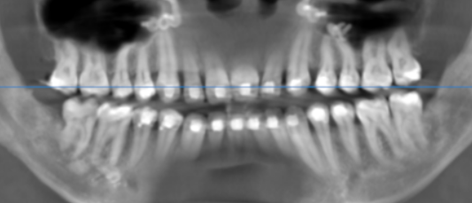

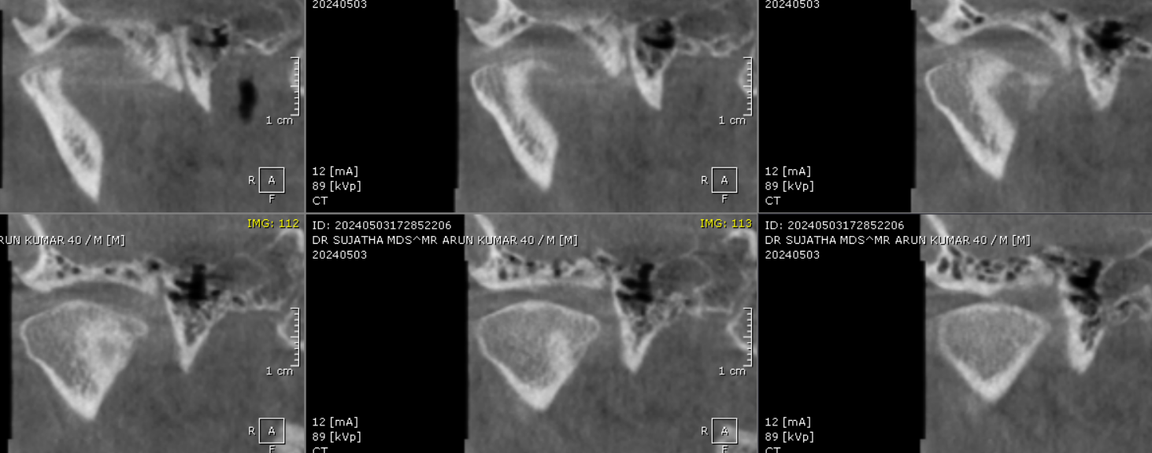
RIGHT TEMPOROMANDIBULAR JOINT
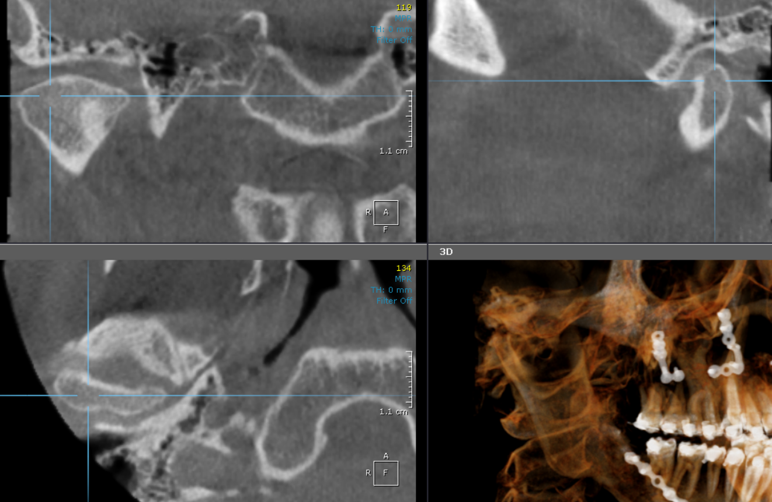

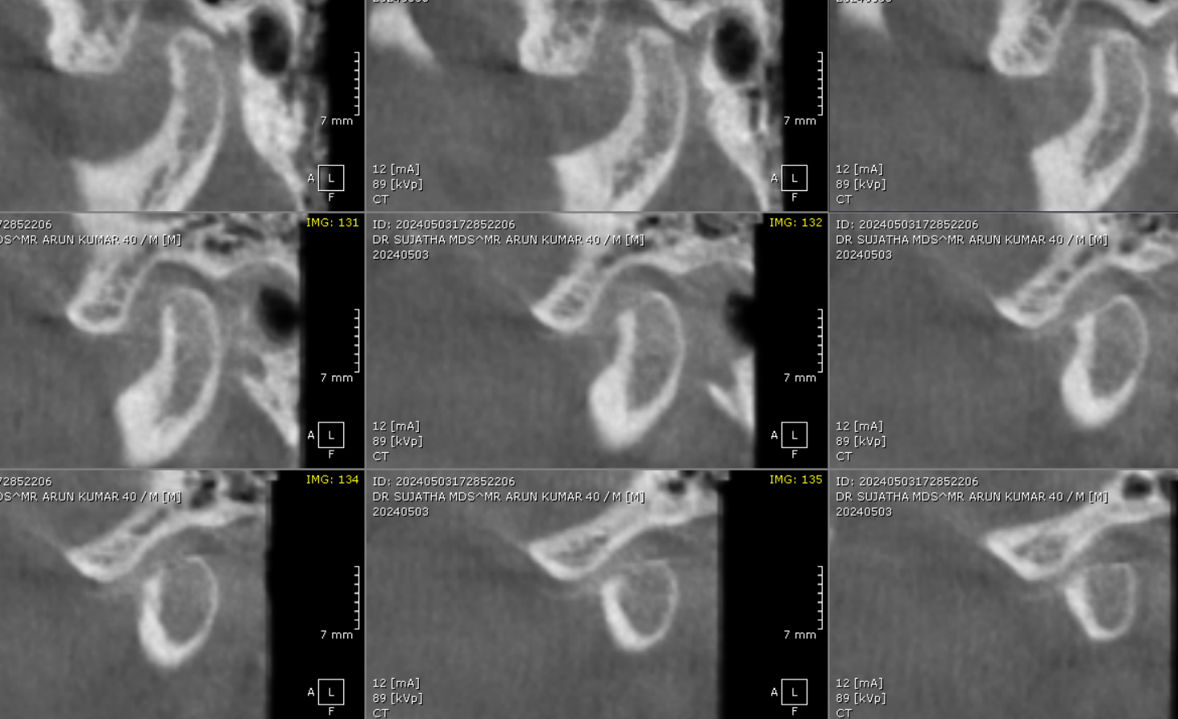

LEFT TEMPOROMANDIBULAR JOINT

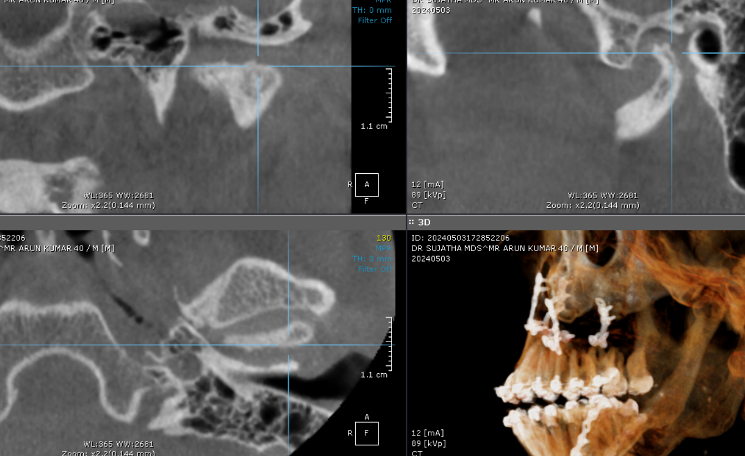

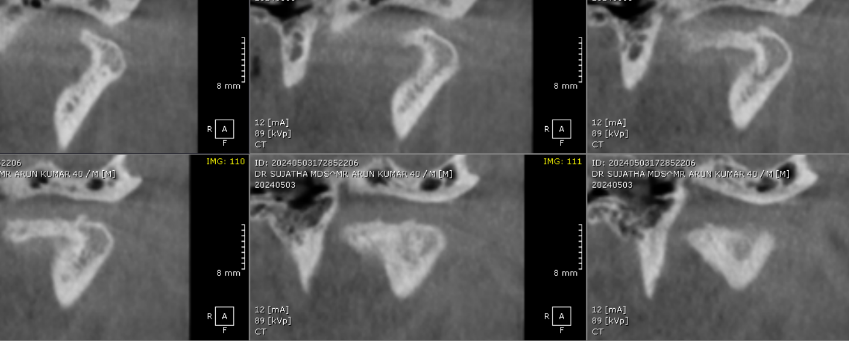

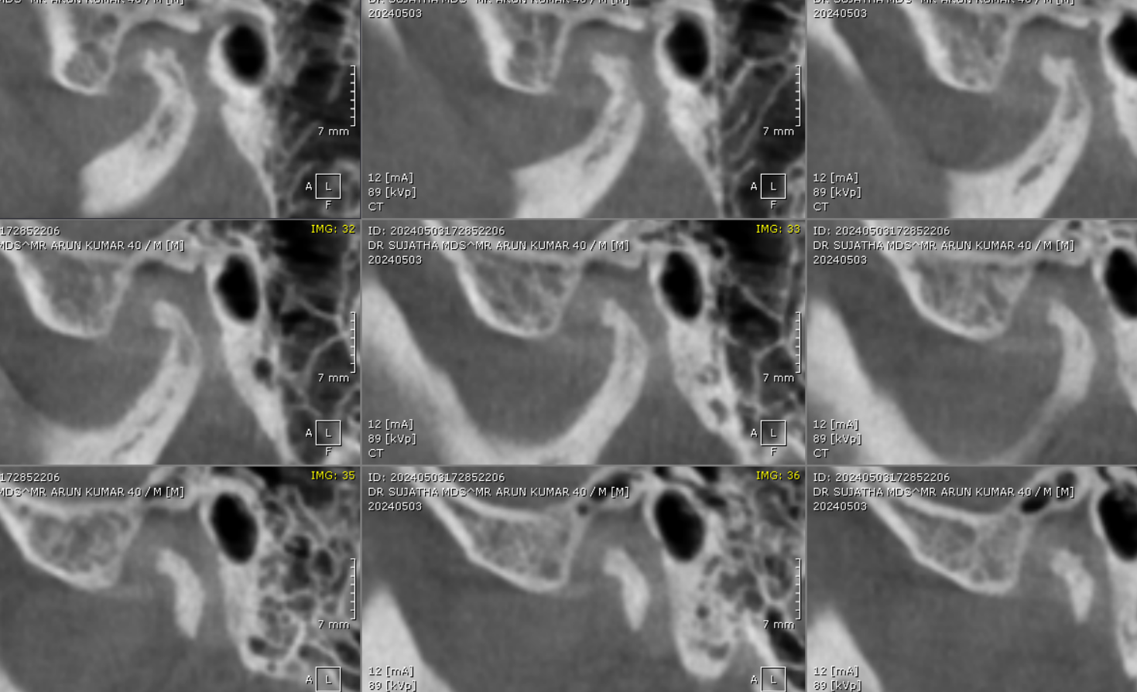

**** End of report ****

